

Q-Learning Management System
User manual

How to add a new Question
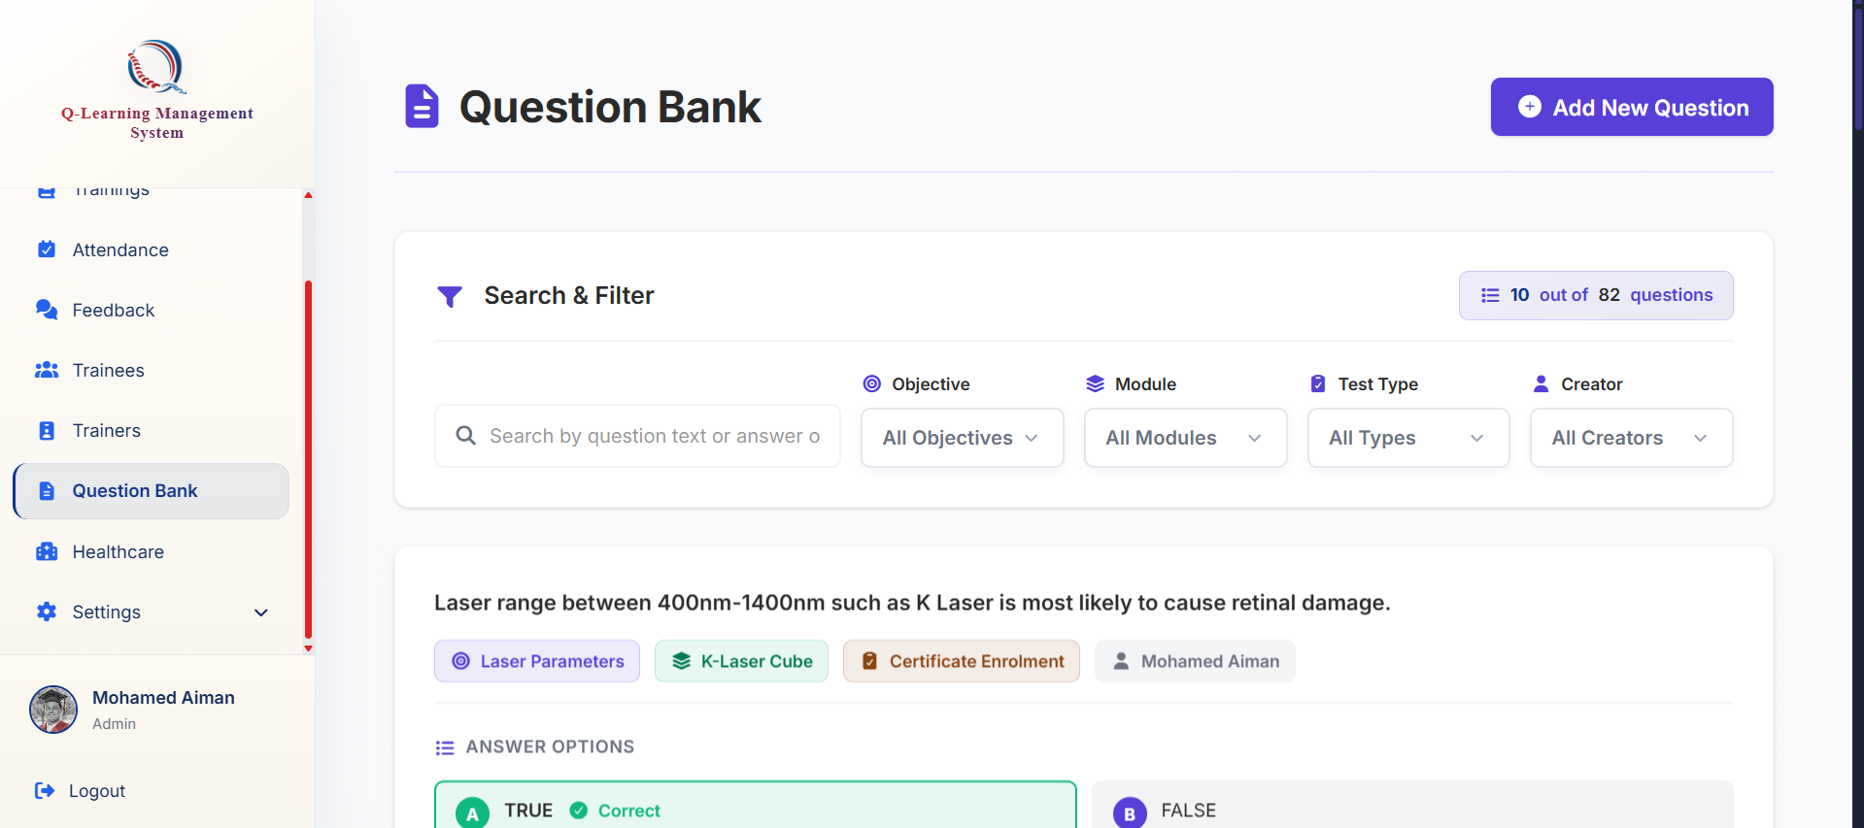
Click on the add Question button

Go ahead to the Questions tab at the bottom of the sidebar
These questions will be used by the system when creating training later. Each training will have a random set of question to keep everything fair and unique



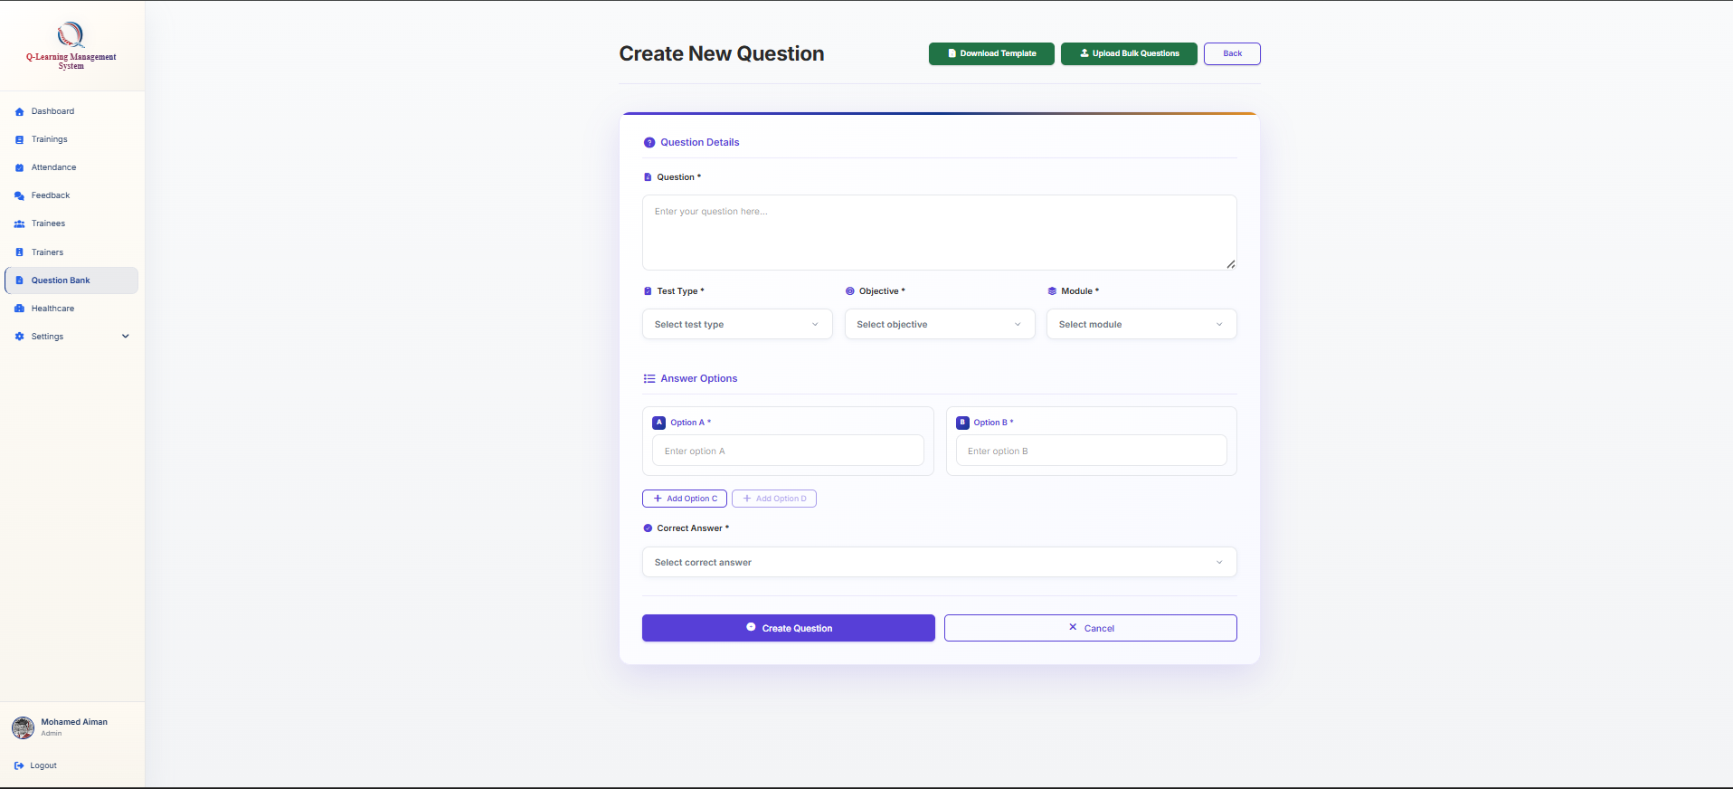
You may also create question in bulk by following these steps:
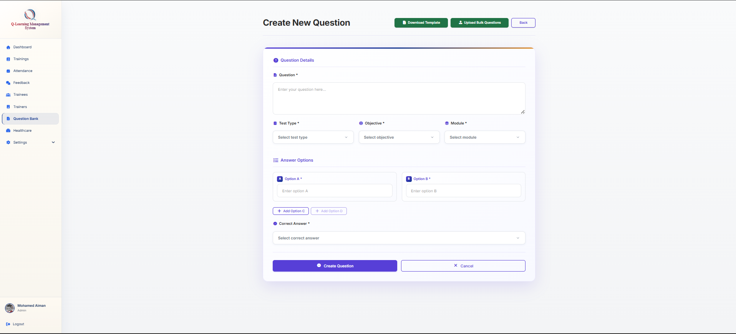

Download the excel template here. A modal will pop up and instruct you on how to use the template as well
The test type must be define as either pre-test post-test or certificate enrollment test
Your question needs to have at least 2 answer options but you may add 3 or max of 4
Click on this button to submit and create
You will be brought to this form where you may fill up the details needed
Then upload your filled excel template here for the system to create your questions in bulk

